- Antipasti (meaning: appetizer)[edit]
- 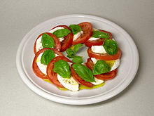
- Insalata caprese
- 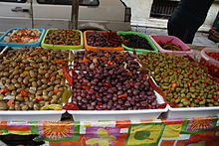
- Spicy olives on sale at the market at Ortigia, in Syracuse, Italy
- Bruschetta – an antipasto from Italy consisting of grilled bread rubbed with garlic and topped with tomatoes, olive oil, salt and pepper
- Bresaola
- Crostini – means "little toast" in Italian language
- Capicollo
- Culatello
- Curried braised rabbit stew
- Insalata caprese
- Insalata russa
- Mozzarelline fritte (fried small mozzarellas)
- Nervetti (pressed beef cartilage seasoned with onions)
- Olives
- Peperoni imbottiti
- Prosciutto e melone (prosciutto and melon)
- Pizzette e salatini
- Salami
- Strolghino
- Tortano
- Verdure in pinzimonio
- Vezione verro
- Breadsticks
- Soup and sauce recipes[edit]
- 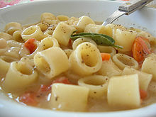
- Pasta e fagioli
- 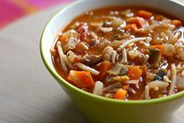
- Minestrone
- Acquacotta
- Agghiotta di lumache (Sicilian snail soup)
- Agliata
- Agrodolce
- Bagna càuda
- Boreto
- Fonduta (fondue)
- Garmugia
- Ginestrata
- Grine Sauce
- Maccu
- Sugo al Pomodoro
- Minestra di ceci
- Minestra di fagioli
- Minestra di pasta con pesce
- Minestrone
- Pasta e fagioli
- Pesto
- Ragù alla bolognese
- Ragù alla salsiccia
- Risi e bisi
- Sciusceddu
- Stracciatella
- Pane (Bread in Italian)[edit]
- 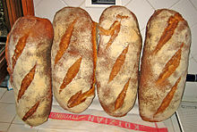
- Pane sciocco
- 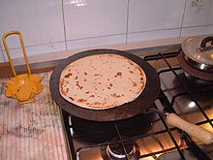
- Preparation of Piadina, a Romagnaflatbread
- Bari
- Biga
- Bozza pratese
- Buccellato
- Casatiello
- Ciabatta
- Ciaccino
- Ciriola (typical bread of Rome)
- Colomba Pasquale
- Coppia Ferrarese
- Crocchè
- Crescentina
- Farinata
- Ficattola
- Focaccia
- Fragguno
- Grissini torinesi
- Michetta (typical bread of Milan)
- Moddizzosu
- Muffuletta
- Neccio
- Pane carasau
- Pane casareccio
- Pane pugliese
- Pane rustico (traditional crusty peasant bread)
- Pane toscano (without salt)
- Pane di Altamura
- Panelle di ceci
- Pane di Genzano (Lazio)
- Pandoro
- Panettone
- Panino
- Penia
- Piadina
- Pita (typical bread of Catanzaro)
- Rosetta (typical bread of Rome)
- Schiacciata
- Taralli
- Testarolo
- Tigella
- Tortano
- Common pizza recipes[edit]
- 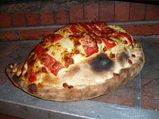
- A calzone
- 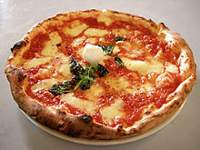
- Neapolitan pizza (Margherita)
- Ai frutti di Mare – an Italian type of seafood pizza that may be served with scampi, mussels or squid^{[8]}
- Calzone – folded over dough usually filled with ricotta and other ingredients
- Focaccia al rosmarino – based on rosemary and olive oil, sometimes served with prosciutto. Usually served as appetizer
- Pizza marinara – based on tomato, oregano and garlic
- Pizza Margherita – based on tomato and mozzarella
- Pizza alla napoletana (or Neapolitan) – tomato, mozzarella and anchovy
- Pizza siciliana – tomato, mozzarella, capperi, olive and anchovy
- Pizza romana – tomato, mozzarella, capperi and anchovy
- Pizza pugliese – tomato, mozzarella and onions
- Pizza capricciosa – with tomato, mozzarella, mushrooms, artichokes, black and green olives
- Pizza quattro stagioni – based on tomato and divided in four sectors, one for each season:
  - Spring: cooked ham (prosciutto cotto) and black olives
  - Summer: artichokes and anchovy
  - Autumn: tomato and mozzarella (like Pizza Margherita)
  - Winter: mushrooms
- Pizza ai quattro formaggi – (four cheese pizza) with four different cheeses (sometimes melted together, sometimes in sectors). With (rossa, red) or without tomato sauce (bianca, white).
- Pizza ai funghi e salsiccia – (Pizza with mushroom and sausage) or boscaiola – with mozzarella, mushrooms and sausages, with or without tomato.
- Pasta varieties - (over 650)[edit]
- Main article: List of pasta
- 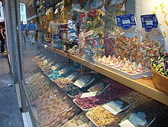
- Some different colours and shapes of pasta, in a pasta specialty store inVenice
- Agnolotti
- Bavette, bigoli, bucatini
- Cannelloni, crespelle
- Cappellini, cappelletti
- Conchiglie
- Ditalini
- Eliche
- Farfalle, festoni, fettuccine, filatieddi, fusilli
- Garganelli
- Gnocchi
- Gnocchi di semolino
- Lasagna, linguine, lumache (snails)
- Maccheroni (macaroni), malloreddus (Sardinian pasta), maltagliati, marille, Marrubini
- Offelle, orecchiette
- Orzo
- Paccheri, paglia e fieno, pansotti, panzarotti, pappardelle, penne, perciatelli, pici, pinzillacchere, pizzoccheri,
- Ravioli, rigatoni
- Spaghetti, spaghetti alla chitarra, strozzapreti, strangozzi, strascinati
- Stelline
- Tacconi, tagliatelle, tagliarini, tonnarelli, tortellini, trenette, trottole, trofie
- Vermicelli
- Ziti
- Pasta dishes[edit]
- 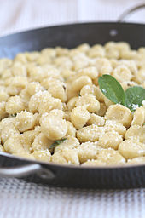
- Gnocchi di ricotta, dressed in butter and sage
- Ciceri e Tria
- Bucatini all'Amatriciana, Bucatini coi funghi, Bucatini alla Sorrentina
- Cannelloni al ragù, cannelloni ai carciofi
- Carbonara
- Fettucine Alfredo
- Linguini with Clam sauce
- Penne all'arrabbiata
- Pansotti alla genovese (a type of huge ravioli)
- Rigatoni con la Pajata, Rigatoni al forno con salsa aurora
- Spaghetti alla Carrettiera, Spaghetti al nero di seppia, Spaghetti alla Puttanesca, Spaghetti con la bottarga, Spaghetti all' aglio, olio e peperoncino, spaghetti indiavolati, Spaghetti Siracusani, spaghetti alla carbonara
- Tagliatelle alla boscaiola, tagliatelle ai carciofi, tagliatelle ai funghi, tagliatelle al pomodoro, tagliatelle al sugo di lepre, tagliatelle al ragù
- Tortelloni alla zucca
- Trofie al pesto, trofie al sugo di noci
- Tortellini, Cjarsons
- Tortelloni ricotta and spinach
- Lasagne
- Ziti
- Ravioli, Klotznnudl
- pasta al pesto
- Rice dishes[edit]
- 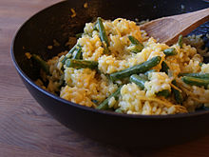
- Risotto with lemon and green beans
- Rice (Riso) dishes are very common in Northern Italy, especially in the Lombardia and Veneto regions, though rice dishes are found in all the country.
- Arancini
- Insalata di riso
- Pomodori col riso
- Risi e bisi (rice and peas)
- Riso e indivia
- Riso tonnato
- Riso valdostano
- Risotto
- Risotto alla milanese or Risotto with saffron
- Risotto con la lüganega
- Riso alla toscana
- Riso al nero di seppia
- Riso con i porcini
- Risotto alla sbirraglia
- Risotto alla zucca
- Risotto di seppie alla veneziana
- Sformato al basilico
- Sformato di riso dolce
- Tiella di riso, patate e cozze
- Risotto ai gamberoni
- Risotto ai quattro sapori
- Risotto al cavolfiore
- Risotto al gorgonzola
- Risotto saltato
- Risotto al Barolo
- Risotto con scamorza e champagne
- Risotto indivia e fiori di zucca
- Risotto allo zafferano con petto d'anatra
- Risotto alla marinara
- Risotto con agoni
- Fish[edit]
- 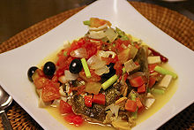
- A variation of acqua pazza featuringblack olives, scallions and mushrooms
- 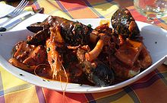
- Cacciucco
- 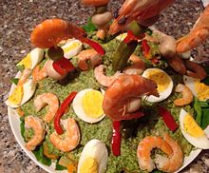
- Cappon magro
- Baccalà
- Boreto alla graisana
- Cacciucco
- Alici, Sardine, Anguilla marinate
- Seppioline in umido
- Missultin e polenta
- Fritata di bianchetti
- Fritto misto di pesce
- Orate al forno
- Acciughe fritte in pastella
- Acciughe in carpione
- Acquadella o latterino fritto
- Acqua pazza
- Agghiotta di pesce spada
- Anguilla marinata
- Baccalà alla vicentina
- Baccalà fritto
- Branzino al sale
- Brodetto di arselle
- Buridda
- Calamaretti fritti
- Calamari in zimino
- Calamari ripieni
- Capesante alla veneziana
- Cappon magro
- Carpaccio di pesce
- Cartoccio di pesce spada
- Cozze alla tarantina
- Cozze fritte alla viareggina
- Cozze ripiene
- Filetti di baccalà
- Filetti di orata al cartoccio
- Frittura mista di pesce
- Grancevola alla veneziana
- Impanata di pesce spada
- Involtini di pesce
- Moscardini lessati alla genovese
- Murena fritta
- Nasello al forno
- Orata arrosto
- Pepata di cozze
- Pesce a scabecciu
- Pesce al cartoccio
- Pesce alla pizzaiola
- Pesce spada alla siciliana
- Pesce Spada arrosto in salmoriglio
- Polpettine di mare
- Sarde a beccafico
- Sarde arraganate (sarde con origano e pane)
- Sarde grigliate
- Sarde ripiene
- Sarde sfiziose panate
- Sardele in saor
- Sbroscia bolsenese
- Scampi a zuppetta
- Scampi gratinati
- Seppie col nero alla veneziana
- Seppie con i piselli
- Seppie ripiene
- Sogliole alla mugnaia
- Spiedini ai frutti di mare
- Spiedini di alici
- Spiedini di anguilla
- Stoccafisso alla genovese
- Stoccafisso alla ligure
- Tonno sott'olio
- Tortiera di cozze
- Totano imbottito
- Triglie alla livornese
- Trotte
- Zuppa di pesce
- Meat dishes and cured meats[edit]
- 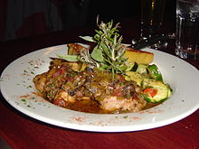
- Rabbit cacciatore
- 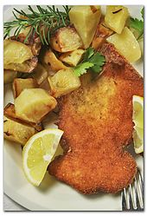
- Cotoletta with potatoes
- Abbacchio brodettato
- Abbacchio alla Cacciatora
- Bistecca Fiorentina (steak florentine)
- Braciole
- Bresaola
- Brodo
- Cacciatore
- Capicollo
- Carne al piatto
- Carne Pizzaiola
- Cevapcici
- Ciabusco Ciabusco
- Coda alla vaccinara
- Cotechino friulano or Musèt
- Cotechino Modena
- Cotoletta alla milanese
- Cotoletta alla petroniana
- Culatello
- Goulash or Gulash
- Guanciale (cured pork jowl)
- Lonza
- Mortadella
- Oca (goose)
- Osso buco
- Pancetta (bacon)
- Pezzetti di cavallo
- Porcaloca
- Prosciutto di Parma
- Prosciutto di San Daniele
- Prosciutto cotto (cooked ham)
- Prosciutto affumicato ( smoked ham)
- Prosciutto crudo
- Saltimbocca alla Romana
- Salame
- Salsiccia (sausages) including Salsiccia cruda
- Soppressata
- Speck Alto Adige PGI
- Speck friulano di Sauris
- Stigghiola
- Trippa alla Romana
- Violino Valtell
- Vitello (veal)
- Vegetables[edit]
- 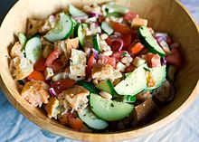
- Panzanella
- Asparagi bianchi e verdi (asparagus)
- Caponata
- Carciofi alla romana
- Crauti (sauerkraut)
- Panzanella – a Tuscan salad of bread and tomatoes that's popular in the summer
- Peperonata
- Pestât
- Pinzimonio
- Wines[edit]
- Further information: Lists of Italian DOCG, DOC, and IGT wines.
- 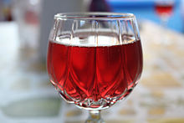
- A glass of Lambrusco
- 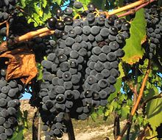
- Sangiovese grapes
- 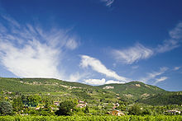
- Vineyards in the Valpolicella region
- Abruzzi
  - Montepulciano d'Abruzzo
  - Trebbiano d'Abruzzo
- Calabria
  - Cirò
- Emilia-Romagna
  - Sangiovese
  - Lambrusco
  - Pignoletto
  - Gutturnio
  - Bonarda
  - Trebbiano
  - Albana
- Campania
  - Greco di Tufo
  - Taurasi
  - Fiano di Avellino
  - Lacryma Cristi
  - Aglianico del Taburno
  - Campi Flegrei
  - Falerno del Massico
  - Solopaca
- Friuli-Venezia Giulia
  - Friulano
  - Pignolo
  - Ramandolo
  - Refosco dal peduncolo rosso
  - Ribolla Gialla
  - Schiopettino
  - Tazzelenghe
  - Verduzzo friulano
- Liguria
  - Cinque Terre
- Lombardy (Lombardia)
  - Franciacorta
  - Oltrepò Pavese
  - Sassella
  - Inferno
  - Grumello
  - Bonarda
  - Barbera
  - Spumante Brut
  - Valcalepio
- Marche
  - Verdicchio
  - Conero
  - Rosso Piceno Superiore
- Piedmont (Piemonte)
  - Alba
  - Acqui
  - Asti
  - Barolo
  - Carema Riserva
  - Colli Tortonesi
  - Gattinara
  - Grignolino
  - Gavi
  - Langhe
  - Monferrato
  - Nebbiolo
  - Ovada
- Apulia (Puglia)
  - Negroamaro
- Sardinia (Sardegna)
  - Cagliari
  - Monti
  - Nuragus
  - Ogliastra
  - Cannonau
- Sicily (Sicilia)
  - Etna
  - Noto
  - Passito di Pantelleria
  - Marsala
  - Nero d'Avola
  - Donna Fugata
- Tuscany (Toscana)
  - Bolgheri
  - Carignano
  - Chianti
  - Colli Apuani
  - Colli Etruria Centrale
  - Colline Lucchesi
  - Elba
  - Scansano
  - Montalcino
  - Montescudaio
  - Nipozzano
  - Vino Nobile di Montepulciano
  - Parrina
  - Pitigliano
  - San Gimignano
  - Val di Chiana
  - Val di Cornia
  - Valdinievole
  - Valle di Arbia
- Umbria
  - Orvieto
  - Torgiano
  - Rosso di Montefalco
  - Sagrantino
  - Grechetto
- Veneto
  - Amarone
  - Bardolino
  - Colli Euganei
  - Conegliano Veneto
  - Custoza
  - Prosecco
  - Soave
  - Valdobbiadene
  - Valpolicella
- Cheeses[edit]
- Further information: List of Italian cheeses, and the more select List of Italian PDO cheeses
- 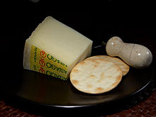
- Asiago
- 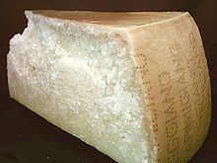
- Parmigiano-Reggiano
- 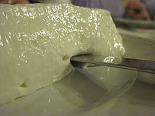
- Stracchino
- Asiago
- Asino
- Bel Paese
- Bitto
- Bra
- Burrini
- Burrata
- Butirro
- Caciocavallo
- Cacioricotta
- Canestrato pugliese
- Casècc
- Castelmagno
- Caprino
- Casiello
- Casu modde
- Ciccillo
- Crescenza
- Crotonese
- Formadi frânt e Formadi salât
- Fontina
- Fiore Sardo
- Formai de Mut dell'Alta Valle Brembana
- Giuncata
- Grana Padano
- Gorgonzola
- Latteria
- Liptauer
- Malga
- Marzolino
- Marzotica
- Mascarpone
- Mozzarella
- Montasio
- Monte Re
- Monte Veronese
- Murazzano
- Parmigiano Reggiano (Parmesan)
- Pecorino di Fossa
- Pecorino friulano
- Pecorino romano,
- Pecorino sardo
- Piacentinu
- Primo Sale
- Provolone
- Puzzone di Moena
- Quartirolo
- Ragusano
- Raschera
- Ricotta affumicata (Scuete fumade)
- Ricotta rifatta
- Ricotta salata
- Robiola
- Slattato
- Stracchino
- Squacquerone
- Tabor
- Taleggio
- Toma
- Tumazzu
- Desserts and pastry[edit]
- Main article: List of Italian desserts
- See also: Sicilian cuisine – Desserts and sweets
- 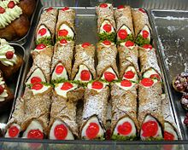
- Cannoli Siciliani
- 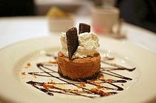
- A semifreddo dessert
- Aceto dolce, fruit preserves made with vinegar, honey, and grape juice^{[9]}
- Anisette (cookie)
- Babà
- Biscotti
- Biscuit Tortoni
- Cannolo siciliano
- Cassata siciliana
- Chiacchiere (angel wings)
- Ciarduna
- Crostata
- Crocetta of Caltanissetta
- Profiterole
- Zuppa Inglese
- Crostoli, Crostui
- Dobos of Trieste
- Frutti (Fruits)
- Frutti di bosco (fruit with pastry)
- Gelato (ice cream)
- Gianduiotto and Gianduia (Hazelnut chocolates or spread)
- Granita
- Gubana
- Macedonia (fruit salad)
- Panna cotta
- Pandoro
- Panettone
- Panforte
- Pastiera
- Piccoli Frutti (small garden fruits)
- Pignolata
- Pizzelle
- Presnitz
- Putizza and Pinza
- Semifreddo
- Sfogliatelle
- Tiramisù
- Torta caprese
- Strucchi or struki
- Strucoli or Strudel (Strudel)
- Struffoli (tiny fritters held together with honey and decorated with multi-colored sprinkles)
- Zabaglione
- Coffee (caffè)[edit]
- 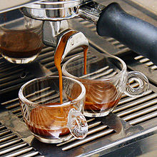
- Espresso
- Bicerin (coffee, hot chocolate and whipped cream, only in Turin)
- Caffè corretto
- Caffè macchiato
- Caffelatte
- Cappuccino
- Espresso (known generally in Italy simply as caffè)
- Grolla dell'amicizia (coffee and grappa served in a traditional bulbous wooden loving cup, shaped like a multi-spouted teapot, and drunk in the Aosta Valley and Piedmont)
- Marocchino, similar to a small cappuccino, invariably served in a glass, and drunk mainly in Turin, in the whole Piedmontand in Milan. Also similar to the espressino.
- Ristretto
- Granita
- Famous dishes[edit]
- 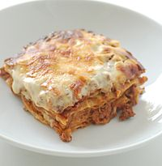
- Lasagne
- Bistecca alla fiorentina (Florentine beefsteak)
- Baccalà alla Vicentina
- Lasagna
- Pasta e fagioli
- Pizza
- Ragù alla bolognese (a meat-based sauce served with tagliatelle or other pasta; the American dish Spaghetti alla Bolognese derives from this)
- Salsiccia
- Ossobuco
- Pollo alla cacciatora
- Tortellini
- Special occasions[edit]
- Feast of the Seven Fishes
- Stuffed Calamari in Tomato Sauce – Squid stuffed with breadcrumbs, garlic, oil/milk, and 3 eggs. The stuffed squid is baked with a white sauce, cheddar and olive oil.
- Deep Fried Fish/Shrimp – Fish/Shrimp dipped into batter and placed into deep fryer. Dish is typically served with lemon and/or cocktail sauce.
- Linguine with Clam Sauce – A mildly spicy dish that combines Linguine pasta served with tomato sauce and cooked clams.
- Marinated Eel – Bite-size cut eel deep fried and seasoned with salt and pepper marinated, after being fried, in a garlic, balsamic vinegar, and sugar sauce.
- Baccalà – De-salted, by soaking water, cod cut into bite-sized portions, pan fried until brown; and served with tomato sauce and pasta.
- Tiramisù – Layered dessert that incorporates layers of coffee soaked ladyfingers, marscapone crème with Marsala, and cocoa powder.
- Unique dishes by region[edit]
- Friuli-Venezia Giulia[edit]
- Asino- cheese of Carnic Prealps
- Brovada or Brovade - cooked turnips that were preserved in marc it:Brovada
- Cjarsons - sort of tortellini with a ricotta filling, of the Carnic Alps
- Cuguluf - leavened cake of Viennese origin
- Formadi frânt" and Formadi salât - cheeses
- Frico - sliced cooked potatotes with onions and Montasio cheese
- Gubana - cake made with a very rich filling of dry fruits, raisins and candied citron
- Gulasch or Goulasch - alla triestina, alla goriziana, alla friulana
- Jota or Iota or Jote - soup made with beans, potatoes and sauerkraut
- Kaiserfleisch - smoked pork, sprinkled with grated horseradish and served with sauerkraut
- Kipfel - small fried crescent, made with a kind of potato dumpling dough
- Montasio -cheese of the Friuli
- Palatschinken - pancake filled with apricot jam or chocolate sauce
- Polenta - all over the region
- Porcina or Porzina - boiled pork served with mustard and horseradish
- Prosciutto di San Daniele DOP, famous ham exported all over the world
- Scuete fumade - sweet smoked ricotta
- Smoked hams of Sauris, of Cormons and of the Carso plateau
- Speck friulano of Sauris
- Veneto[edit]
- Galani or Crostoli - pastries
- Pasta e fagioli - a soup of pasta and beans
- Polenta e osei - polenta accompanied with roasted wild birds
- Radicchio e pancetta - raw or cooked radicchio salad with pancetta
- Risi e bisi - rice with young peas
- Lesso e pearà - boiled meats with pepper sauce, most unique of the Province of Verona
- Sarde in saor - fried, marinated sardines
- Bigoli con l'arna - a type of pasta similar to Tagliatelle but bigger with a sauce of liver of the duck
- Trentino-Alto Adige/Südtirol[edit]
- 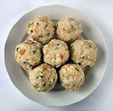
- Canederli
- Speck – juniper flavored ham
- Strangolapreti – spinach dumplings
- Canederli or Knödel – dumplings made with leftover bread and cold cuts
- Minestrone di orzetto – barley soup
- Carnsalada e fasoi – aromatized salt beef with beans
- Crauti - Sauerkraut
- Lombardia[edit]
- 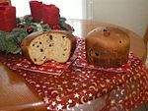
- Panettone
- Tortelli di zucca – ravioli with a squash filling
- Risotto alla milanese – A stirred rice dish made with Vialone or Carnaroli rice flavored with saffron and beef marrow
- Panettone – a Milanese Christmas traditional sweet bread made with a yeast and egg dough along with candied citrus peel, andraisins
- Torrone – a candy made of honey, sugar, and egg white, with toasted almonds or hazelnuts
- Mostarda di Cremona – a sweet/spicy sauce made with candied fruits and meant to be served along boiled beef meat.
- Pizzoccheri – buckwheat tagliatelle dressed with potatoes, greens (often Swiss Chard or Spinach), butter and Bitto cheese: a speciality of the Valtellina.
- Val D'Aosta[edit]
- 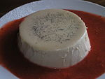
- Panna Cotta
- Zuppa di Valpelline - savoy cabbage stew thickened with stale bread
- Tortino de riso alla valdostana - rice cake with ox tongue
- Piedmont (Piemonte)[edit]
- Brasato al vino - stew made from wine marinated beef
- Risotto alla piemontese - risotto cooked with meat broth and seasoned with nutmeg, parmesan and truffle
- Paniscia di Novara – a dish based on rice with borlotti beans, salame sotto grasso and red wine
- Panissa di Vercelli" – a dish based on rice with borlotti beans, salame sotto grasso and red wine
- Gnocchi di semolino alla romana - semolina dumpling
- Bagna cauda - A hot dip based on anchovies, olive oil and garlic blanched in milk, to accompany vegetables (either raw or cooked), meat or fried polenta sticks
- Carne cruda all'albese - steak tartare with truffles
- Vitello tonnato - veal in tuna sauce
- Bollito misto
- "Salame sotto Grasso" - pork salami aged under a thick layer of lard
- "Rane Fritte" - fried frogs
- "Riso e Rane" - risotto with frogs
- Lepre in Civet - jugged hare
- Pere San Martin al vino rosso — winter pears in red wine
- Panna cotta - sweetened cream set with gelatin
- Liguria[edit]
- Pesto - Probably Liguria's most famous recipe, widely enjoyed beyond regional borders, is a green sauce made from basil leaves, sliced garlic, pine nuts, pecorino or parmigiano cheese (or a mix of both) and olive oil. Traditionally used as a pasta dressing (especially with gnocchi or trenette, it is finding wider uses as sandwich spread and finger-food filler)
- Pizza all'Andrea – focaccia-style pizza topped with tomato slices (not sauce) onions and anchovies
- Scabeggio - fried fish marinated in wine, garlic, lemon juice and sage, typical of Moneglia
- Baccalà fritto - morsels of salt cod dipped in flour batter and fried
- Torta pasqualina – savory flan filled with a mixture of green vegetables, ricotta and parmigiano cheese, milk and marjoran; some eggs are then poured in the already-placed filling, so that their yolks will remain whole when cooked
- Buridda – seafood stew
- Bagnun (literally Big Bath or Big Dip) a soup made with fresh anchovies, onion, olive oil and tomato sauce where crusty bread is then dipped; originally prepared by fishermen on long fishing expeditions and eaten with hard tack instead of bread.
- Mosciamme - originally a cut of dolphin meat dried and then made tender again thanks to immersion in olive oil, for several decades tuna has replaced dolphin meat.
- Mescciüa - a soup of chickpeas, beans and wheat grains, typical of eastern Liguria and likely of Arab origin
- Cima alla genovese - this cold preparation features an outer layer of beef breast made into a pocket and stuffed with a mix of brain, lard, onion, carrot, peas, eggs and breadcrumbs, then sewn and boiled. It is then sliced and eaten as an entrée or a sandwich filler
- Stecchi alla genovese - wooden skewers alternating morsels of leftover chicken meats (crests, testicles, livers...) and mushrooms, dipped in white bechamel sauce, left to dry a bit and then breaded and fried
- Pansoti - triangle-shaped stuffed pasta filled with a mix of borage (or spinach) and ricotta cheese, they can be eaten with butter, tomato sauce or a white sauce made with either walnuts or pine nuts (the latter two being the more traditional ligurian options)
- Bianchetti - Whitebait of anchovies and sardines, usually boiled and eaten with lemon juice, salt and olive oil as an entrée
- Maccheroni con la Trippa - A traditional savonese soup uniting maccheroni pasta, tripe, onion, carrot, sausage, "cardo" which is the Italian word for Swiss chard,parsley, and white wine in a base of capon broth, with olive oil to help make it satisyfing. Tomato may be added but that is not the traditional way to make it. (Traditional ingredients: brodo di gallina o cappone, carota, cipolla, prezzemolo, foglie di cardo, trippa di vitello, salsiccia di maiale, maccheroni al torchio, vino bianco, burro, olio d'oliva, formaggio grana, sale.)
- Condigiun - a salad made with tomatoes, bell peppers, cucumber, black olives, basil, garlic, anchovies, hard boiled egg, oregano, tuna.
- Sgabei - fritters made from bread dough (often incorporating some cornmeal in it)
- Testa in cassetta - a salami made from all kind of leftover meats from pork butchering (especially from the head)
- Galantina - similar to Testa in cassetta but with added veal meat
- Torta di riso - Unlike all other rice cakes this preparation is not sweet, but a savoury pie made with rice, caillé, parmigiano and eggs, it can be wrapped in a thin layer of dough or simply baked until firm
- Panera genovese - a kind of semifreddo rich in cream and eggs flavoured with coffee, similar to a cappuccino in ice cream form
- Cappon Magro – a preparation of fish, shellfishes and vegetables layered in an aspic
- Cobeletti – sweet corn tarts
- Latte dolce fritto - a thick milk based cream left to solidify, then cut in rectangular pieces which are breaded and fried
- Pandolce – sweet bread made with raisins, pine nuts and candied orange and cedar skins
- Panissa and Farinata – chickpea-based polentas and pancakes respectively
- Farinata di zucca - a preparation similar to chickpea farinata substituting pumpkin for the legumes' flour as its main ingredient, the end result is slightly sweeter and thicker than the original
- Agliata - Pesto's direct ancestor, a spread made from garlic cloves, egg yolk and olive oil pestled in a mortar until creamy
- Trenette col pesto - Pasta with Pesto (Olive Oil, garlic, Basil, Parmigiano and Pecorino Sardo cheese) sauce
- Emilia-Romagna[edit]
- 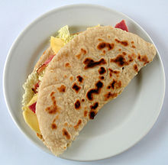
- Piadina
- 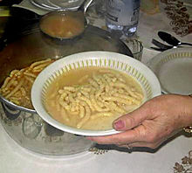
- Passatelli
- 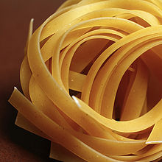
- Tagliatelle
- Zampone - stuffed pig's trotter, fat, but leaner than cotechino's, stuffing; to be boiled (from Modena)
- Cotechino - big raw spiced pork sausage to be boiled, stuffing rich in pork rind (from Emilia provinces)
- Cappello da prete - "tricorno" hat shaped bag of pork rind with stuffing similar to zampone's, to be boiled (from Parma, Reggio Emilia and Modena)
- Erbazzone, spinach and cheese filled pie from Reggio Emilia
- Fave stufate - broad beans with mortadella
- Torta Barozzi o Torta Nera - Barozzi tart or black tart (a dessert made with a coffee/cocoa and almond filling encased in a fine pastry dough (from Modena)
- Tortelli - Uusally square, made in all Emilia-Romagna, filled with swiss chard or spinach, ricotta and Parmigiano Reggiano in Romagna or ricotta, parsley, Parmigiano Reggiano in Bologna (where they are called Tortelloni) and Emilia, or with potatoes and pancetta in the Apennine mountains
- Tortellini - small egg pasta navel shapes filled with lean pork, eggs, Parmigiano-Reggiano, Mortadella, Parma Ham and nutmeg (from Bologna and Modena: according to a legend, they were invented in Castelfranco Emilia by a peeping innkeeper after the navel of a beautiful guest)
- Cappelletti - small egg pasta "hats" filled with ricotta, parsley, Parmigiano Reggiano and nutmeg, sometimes also chicken breast or pork and lemon zest, from Emilia, in particular Reggio.
- Cappellacci - large size filled egg pasta with chestnut puree and sweet Mostarda di Bologna, from Romagna.
- Lasagne - green or yellow egg pasta layered with Bolognese Ragù (meat sauce) and bechamel
- Cannelloni, Crespelle and Rosette - pasta filled with bechamel, cream, ham and others
- Piadina Pancake shaped flat bread (from Romagna) which can be smaller and higher or larger and very thin
- Passatelli - noodles made of breadcrumbs, Parmigiano Reggiano, cheese, lemon zest and nutmeg from Romagna
- Crescentine baked on Tigelle - (currently known also as Tigelle that is the traditional name of the stone dies which Crescentine were baked between) a small round (approx. 8 cm diameter, 1 cm or less thick) flat bread from the ModenaAppennine mountains
- Parmigiano-Reggiano - prized ancient long-aged cheese from Reggio Emilia,Parma. Modena and Bologna
- Aceto Balsamico Tradizionale di Modena and Aceto Balsamico Tradizionale di Reggio Emilia very precious, expensive and rare sweet, dark, sweet and aromatic vinegar, made in small quantities according to elaborated and time consuming procedures (it takes at least 12 years to brew the youngest Aceto Balsamico) from local grapes must (look for the essential "Tradizionale" denomination on the label to avoid confusing it with the cheaper and completely different "Aceto Balsamico di Modena" vinegar, mass-produced from wine and other ingredients
- Pan Pepato - very rich Christmas dried fruit and nut dessert with almonds, candies and a lot of sweet spices
- Spongata - very rich Christmas time thin tart: a soft crust with flour sugar dusting, stuffed with finely broken almonds and other nuts, candies and a lot of sweet spices, from Reggio Emilia
- Mortadella - baked sweet and aromatic pork sausage from Bologna
- Culatello - a cured ham made with the most tender of the pork rump: the best is from the small Zibello area in Parma lowlands
- Salame Felino - salami from Parma province
- Coppa - cured pork neck form Piacenza and Parma
- Garganelli - typical Romagna quill shaped egg pasta usually dressed with Guanciale (cheek bacon), peas, Parmigiano Reggiano and a hint of cream.
- Gramigna con salsiccia - typical Bologna short and small diameter curly pasta pipes with sausage ragù.
- Pisarei e Fasò - pasta peas with beans from Piacenza
- Torresani - rosted pigeons popular in Emilia
- Salamina da Sugo - soft sausage from Ferrara, seasonal.
- Spalla di San Secondo - gourmet salami from a small town near Parma; it is made with seasoned pork shoulder, stuffed in cow bladders and slowly boiled or steamed.
- Ciccioli - cold meat made with pig's feet and head from Modena
- Squacquerone - Sweet, runny, milky cheese from Romagna
- Crescentine — flat bread from Bologna and Modena: to be fried in pork fat or baked between hot dies (see Tigelle above)
- Gnocco Fritto - fried pastry puffs from Modena (Gnocco Fritto was a very local name: until few decades ago it was unknown even in neighbouring Emilian provinces where different denominations, i.e. Crescentine Fritte in Bologna, for similar fried puffs)
- Piadina Fritta Fried Romagna pastry rectangles
- Tortelli alla Lastra- Griddle baked pasta rectangles filed with potato and pumpkin puree and sausage or bacon bits
- Borlengo from the hills South of Modena
- Tagliatelle all' uovo - egg pasta noodles, very popular across Emilia-Romagna; they are made in slightly different thickness, width and length according to local practise (in Bologna the authentic size of Tagliatelle alla Bolognese is officially registered at the local Chamber of Commerce)
- Pesto di Modena - cured pork back fat pounded with garlic, rosemary and Parmigiano-Reggiano used to fill borlenghi and baked crescentine

